44.8: 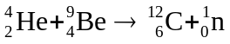
We take the masses for these reactants from Table 43.2, and use Eq. 43.23

